Joint Force Air Component Command (JFACC) TTP

**Purpose:**

The intention with this document is to provide volunteers in the 132nd JFACC role the necessary background and information about the way JFACC works in a 132nd context. In addition, the document will help campaign designers/mission makers understand how JFACC can be used, and what products are needed from campaign designers/mission makers if they want to use a player staffed by JFACC for the campaign.

**Disclaimer:**

The terms and processes described in this document is drawn from real world references, but are simplified and adjusted to meet the need for conducting a campaign in DCS.

**How to read:**

Chapter 2 contains a broad and theoretical explanation to provide context and understanding for air campaign planning (how to plan a campaign) and the execution of the air campaign (through the air tasking cycle).

Chapter 3 contains a condensed step by step procedure for JFACC adjusted for planning and executing 132nd hosted campaigns (in line with chapter 2).

Chapter 4: contains best practice for how to organize and work together as JFACC volunteers.

# Chapter 1: Terms

### End State

A end state is the set of required conditions that defines achievement of all objectives. The end state should account for a wide variety of task the force may need to accomplish. The end state describes the set of conditions to meet the conflict termination criteria (war is over).

### Objective:

The objective is why the mission is being conducted and should be determined first. Objectives may be broad or defined by the end state.

An objective is clearly defined, decisive and attainable. Objectives and their supporting effects provide the basis for identifying tasks to be accomplished.

There are four primary considerations for an objective:

* An objective establishes a single result
* An objective (and associated conditions/effects) should link directly or indirectly to higher-level objectives or to the end state. JFACC participants need to know the higher level objective (CJTF objectives, found in the CJTF operations order) and should be able to identify how their objective support the higher level objective
* An objective is specific and unambiguous
* An objective does not imply ways and/or mean - it is not written as a task

Objectives describe what must be achieved to attain the desired end state.

### Effects

An effect is a physical and/or behavioral state of a system that results from an action, a set of actions, or another effect. A desired effect can be thought of as a condition that can support achieving an associated objective and an undesired effect is a condition that can inhibit progress toward an objective.

Effects describes the conditions related to the objectives:

* Desired effects describe conditions needed to achieve objectives
* Undesired effects describe conditions that will impede achievement of objectives.

### Centre of Gravity (COG)

Center of Gravity: That characteristic, capability, or locality from which a military force, nation, or alliance derives its freedom of action, physical strength, or will to fight.

### Critical Capability (CC)

A means that is considered a crucial enable for a center of gravity to function as such, and is essential to the accomplishment of the specified or assumed objective(s).

### Critical Requirement (CR)

An essential condition, resource and means for a critical capability to be fully operational.

### Critical Vulnerability (CV)

An aspect of a critical requirement (CR), which is deficient or vulnerable to direct or indirect attack that will create decisive or significant effects.

### Tasks

Tasks describe friendly actions to create desired effects or preclude undesired effects.

### Mission

Mission describes the organization’s essential task or task(s) and purpose.

### Target set

A ‘target set’ is a group of interrelated target categories within an actor’s system, such as transportation/lines of communication, electric power and adversary media.

### Target category

A ‘target category’ is a group of targets serving the same function, such as bridges, roads, radio broadcasts and newspapers.

### Joint Task Force (JTF)

A force consisting of units from more than one service. For example air, sea and land. All 132nd operations are considered joint operations since they use both air force aviation and naval aviation.

### Combined Joint Task Force (CJTF)

A joint force that includes more than one nation. All 132nd operations are considered combined, since members of the 132nd are from various nations.

### Time Sensitive Target (TST)

Time-sensitive targets (TSTs) are those targets requiring an immediate response because they pose (or will soon pose) a danger to friendly forces or are highly lucrative, fleeting targets of opportunity whose successful engagement is of high priority to achieve campaign objectives.

### Apportionment

Air apportionment is the determination and assignment of the total expected effort by percentage and/or priority that should be devoted to the various air operations and/or geographic areas for a given period of time. Air apportionment allows the JFC to ensure the weight of the joint air effort is consistent with campaign phases and objectives. Given the many functions that the joint air effort can perform, its AOR/JOA-wide application, and its ability to rapidly shift from one function to another, JFCs pay particular attention to its apportionment. JFCs normally apportion the air effort by priority or percentage of effort into geographic areas, against mission-type orders, and/or by categories significant for the campaign. These categories can include, but are not limited to, strategic attack, interdiction, counter air, maritime support, and close air support.

### Master Air Attack Plan (MAAP)

A plan that contains key information that forms the foundation of the joint air tasking order. Sometimes referred to as the air employment plan or joint air tasking order shell. Information that may be found in the plan includes joint force commander guidance, joint force air component commander guidance, support plans, component requests, target update requests, availability of capabilities and forces, target information from target lists, aircraft allocation, etc.

## Roles

### Joint Force Commander (JFC) (Mission Designer)

JFC is the commander of a JTF or a CJTF. JFC will provide the overall guidance and mission to all components (land, sea, air and special operations).

### Joint Force Air Component Command (JFACC) (Player volunteers)

Joint Force Air Component Command (JFACC) is the headquarter of the Joint Air Forces in the operation (Both Navy and Air Force, so for us in the 132nd, all air forces)

JFACC plans and executes air campaigns. JFACC have a role both in campaign planning for a campaign, but also for the planning for each ATO day (each event)

The JFACC role is about giving the direction and guidance for air operations. JFACC will publish its guidance before each event in the Air Operations Directive (AOD), and this direction and guidance will be used by everyone involved, especially AWACS controllers and mission commanders/flight leads for planning packages or flights.

JFACC also holds responsibility as Airspace Controlling Authority (ACA) and Area Air Defense Commander (AADC) for any 132nd campaign.

If needed JFACC may also request support from other component commands (Land, Sea and Special Operations).

### Virtual Intelligence Directorate (VID) (Mission Designer)

VID provides intelligence injects into the campaign. This can be considered a broader intelligence agency than VIS. VID is the way the mission designer can inject relevant or irrelevant information into the campaign, that can be picked up by VIS and JFACC and used for the execution of subsequent events based on the new information.

### Virtual Intelligence Service (VIS) (Player volunteers)

The VIS role is about providing intelligence for the rest of the organization. The individuals functioning as VIS will try to make sense of the battlefield based on the reports from pilots after events, in addition to intelligence from VID.

VIS has a dual purpose:

1. Support the event planning on a higher level (support to JFACC)
2. Support the event planning on a tactical execution level (support to pilots)

VIS may have intelligence gaps, and can request submit a IR (Information Requirement) to JFACC. JFACC may task specific flight with providing the information asked about in the information requirement.

### Land Component Command (LCC) (Mission Designer)

This is the land component of the Joint Force, and controls the fight taking place on the ground. The land forces are slow to maneuver, but are often the decisive factor. MCC and JFACC will often have a supporting role to help LCC reach their objectives.

### Maritime Component Command (MCC) (Mission Designer)

This is the maritime component of the Joint Force, consisting of surface ships, submarines. Naval aviation is for the 132nd purposes controlled by JFACC. Surface ships operating together may form a Surface Action Group (SAG) with mutual support. MCC may have several SAG`s. Maritime units are fewer in number than land units, and can easily be task organized in various SAG formations based on the need for the specific mission.

### Special Operations Component Command (SOCC) (Mission Designer)

This is the special operations component of the Joint Task Force. Special operations can be used for sensitive missions, or demanding missions that LCC is not suited for. Typical insertions deep behind the enemy line to provide intelligence, or to support attacks by JTACs.

## Products

### Operation Order

The operation order is the overall order from the Joint Force Commander (JFC). It will contain an overall situation, an overview of friendly and enemy forces. It will also contain the mission and the commander’s intent with the operation. Furthermore the operation order contains a broad concept of operation and objectives to be met. The operation order will also list specific tasks to the component commands (Land, Air, Sea, Special operations)

### Joint Force Commander Direction & Guidance (JFC D&G)

When necessary (before an event or a new phase), JFC may see it necessary to provide additional direction and guidance for the overall campaign. This will be published in the JFC D&G document.

### Joint Air Operations Plan (JAOP)

The JAOP is JFACC`s overall plan on how to conduct the campaign. The JAOP will have the mission for JFACC together with the commander’s intent and the objectives for JFACC. It will contain on the concept of operation through information of what is planned to be conducted during the various phases in the operations. The phases may be given in the Operations Order, but JFACC can add new phases or break down the phases in various sub phases. The JAOP will also include a timeline over the various phases and sub phases. The JAOP is created prior to the first event and will be the guiding document for further events.

### Air Directions Directive (AOD)

### Air Tasking Order (ATO)

### Airspace Control Order (ACO)

Per event

### Airspace Control Plan (ACP)

Overall plan with all airspace information

### Special Instructions (SPINS)

This is a document used for mission designer and JFACC to place information for the campaign. To be read by all pilots and controllers participating on an event.

### Joint Target List (JTL)

### Joint Prioritized Target List (JPTL)

Part of AOD?

# Chapter 2: Theory

## Air Campaign planning

5 steps JAOP plan development

### Step 1: Operational Environment Research.

This step is focused on gaining information about friendly and adversary capabilities and intentions, doctrine, and the environment in which the operations will take place. The goal of this phase is to gain an understanding of the area of operations, the adversary, and friendly forces available to accomplish the JFC’s objectives. Key factors such as threats and airbase availability will affect the strategy development process. A larger enemy air threat requires more time and assets dedicated to the achievement of aerospace superiority, to the initial detriment of

other missions. Airfields further from the AOR may be used by long-range or tanker-assisted assets, but the increased mission duration will reduce the number of targets that can be attacked in a given period. Such airfields may be at lower risk to enemy air and missile attack,

however, providing a tradeoff between efficiency and survivability.

### Step 2: Centers of Gravity Identification.

Within the framework of the step process, Step 1, Operational Environment Research, almost naturally flows into a more detailed, in-depth study of **your adversary** known as **center of gravity (COG) analysis**. This analysis should provide you with as clear a picture as possible of how an adversary functions; of his strengths, and of his possible vulnerabilities to dislocation and exploitation by air power.

Clausewitz was the first to apply the term “*center of gravity”* to warfare. He described a center of gravity as, “**the hub of all power and movement, on which everything depends**.” Clausewitz clarifies this description by stating that “the ultimate substance of enemy strength must be [traced back to the fewest possible sources, and ideally to one alone.” Other writers have used terms such as “vital centers,” “key nodes,” “decisive points,” or “critical vulnerabilities” to approach the same concept. They were partly right. The “hub of power and movement” itself is the “center of gravity.” Take the “hub” away and the enemy system ceases to function or the enemy ceases to act against you. That “hub” has certain characteristics, *among them critical vulnerabilities*. These vulnerabilities will naturally flow into target sets. From these target sets, individual targets can be identified and attacked as required to support the campaign’s objectives. Given proper analysis, successfully attacking those targets will decisively affect the center of gravity.

**COG Analysis.** COG analysis is important to targeting efforts because it identifies the adversary’s strengths and weaknesses, and how the adversary organizes, fights, and makes decisions. This analysis helps identify where those sources of power are vulnerable, where critical nodes within them are, and how they can be exploited.

Analysis begins with the COG as a source of power. The analysis identifies the inherent abilities that allows the COG to act as such (critical capabilities); identifies the essential conditions, resources, or means (critical requirements) that allow the COG to operate; and then determines where those critical requirements are vulnerable (critical vulnerabilities [CVs]). Collectively, these are called critical factors. While it can sometimes be difficult to pick CVs from critical requirements or translate the former into explicit target sets, analysis performed during target development can help “operationalize” this technique’s insights.

COGs are nouns—tangible or intangible sources of power. CC can be thought of as verbs—things a COG does. CRs are nouns—those things a critical capability needs to function as such. CVs are those critical requirements that are vulnerable.

Example:

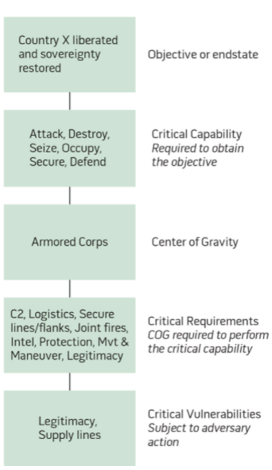

In order to achieve the JFC’s objectives, the campaign planner (JFACC) must ask the following:

* which COGs do I try to affect?
* how do I affect them?
* to what extent do I affect them?
* When do I affect them?”

The answers come from a comprehensive center of gravity analysis.

**Types of attack.** As JFACC planners, your COG analysis should yield an understanding of which enemy systems are critical to his resistance, which of these are vulnerable to attack, and which are feasible to attack. Attack,of course, does not always imply physical destruction of a COG or its components. Centers of gravity may be attacked **directly** or **indirectly** (or in a combination of the two).

* ***Direct*** *attack*, as its name implies, involves *attacking the COG itself or engaging it in decisive combat*.
* ***Indirect*** *attack involves causing the same or similar effect by attacking a COG’s supporting or related elements*. Another indirect technique involves attacking targets that may produce a new, more accessible COG. For example, if an individual national leader is identified as a COG, direct attack on his/her person might accomplish the objective of ending the war. If, however, such an attack is not allowed by national policy or the law of armed conflict, then you might have the *same effect* by attacking the leader’s ability to communicate with the components of his system.

**Parallel Attack.** Centers of gravity should be attacked as systems. Airpower is unique in its ability to affect every facet of a COG. If POL is the COG, it can be attacked from the point where it comes out of the ground all the way to the point where it goes into a combat vehicle (or into an enemy leader’s electrical generator). There may also be key elements in a COG’s target set that look like they could bring down the COG if attacked independently, but which should be attacked in parallel with other elements (resources permitting) in order to stress the entire target system. This has the added benefit of reducing the impact of errors in your analysis caused by fog and friction, and further reduces the enemy's reconstitution potential. Hedge your bets by attacking as much of the system as you can afford—until you achieve your objective.

**COGs and targets.** Also note that *COG analysis does not lead to an exhaustive list of targets*. There are some targets, often unrelated to enemy COGs and their critical vulnerabilities, that must be struck, either to enable attacks elsewhere within the enemy system or to defend your own centers of gravity. An example of an enabling attack might be suppressing enemy air defenses (in a case where those defenses were not themselves identified as a COG) in order to strike a COG-associated target set deep in the enemy’s country.

**What really matters:**

The following are COG-related ideas that are critical for planners (from planning team members to commanders) to know and believe:

* A COG is based on and linked to an objective; indeed, it is what accomplishes an objective.
* COG identification and analysis provide the foundation for COA development.
* COG is a planning concept; objectives or capabilities may change in execution, necessitating re-analysis of COGs.
* A great part of the value of COG analysis to planners are the discussion and debate that arise from conducting the analysis.
* Identification and analysis of COGs must be done as discretely as possible for focus and clarity in COA development.
* Multiple varying objectives may necessitate multiple COGs.

In summary, centers of gravity are those things from which an actor in a conflict derives his power or freedom of action. We analyze them in order to determine critical vulnerabilities within them that will yield the most effective use of air power in achieving a campaign’s objectives.

Visualization of COG, Critical capabilities, critical requirements and critical vulnerabilities:

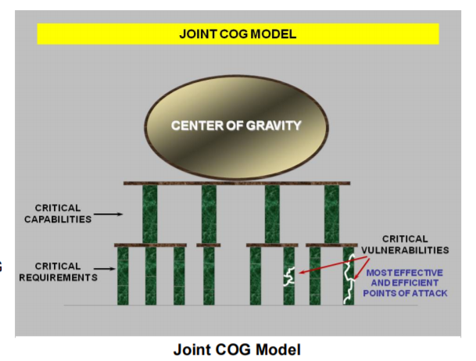

Figur 2‑1 :https://www.doctrine.af.mil/Portals/61/documents/AFDP_3-0/3-0-D30-Appendix-1-COG-Analysis.pdf

Example COG analysis:



Figur 2‑2 : https://ndupress.ndu.edu/media/news/article/969689/lets-fix-or-kill-the-center-of-gravity-concept/

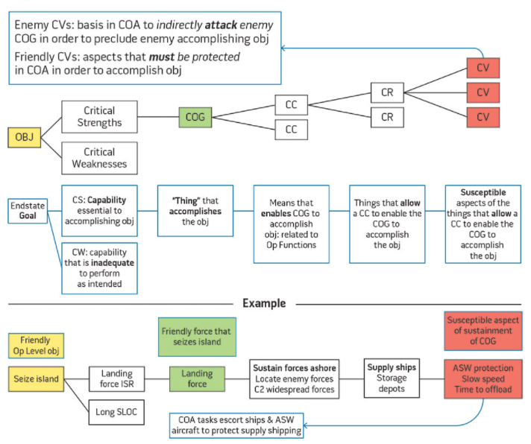

Figur 2‑3 https://ndupress.ndu.edu/JFQ/Joint-Force-Quarterly-82/Article/793278/the-primacy-of-cog-planning-getting-back-to-basics/

### Step 3: Objective Determination.

The output of this step is clearly defined and quantifiable JFACC objectives that will contribute to the accomplishment of the JFC’s overall objectives.

Air objectives should logically flow from the JFC`s objectives. **If** **you cannot tie an air objective to** **JFC objectives,** **do not commit resources to it** unless you believe an objective has been overlooked. Some intermediate air objectives (those necessary to achieve the end goals of a primary objective) may not appear to be directly related to the JFC objectives. They are, however, appropriate air objectives and should be included in the air plan. For example, some level of air and space control gained through counterair operations will probably be a necessary prerequisite for a primary objective dealing with paralyzing the enemy.

The development of objectives and guidance is the first and the most critical step in the targeting cycle. Objectives and guidance identify what is to be achieved and under what conditions and parameters. An objective must be understandable, attainable, measurable, and allow room for a solution.

An objective defines the specific targeting problems to be solved. Measurable, definitive objectives must be given or derived from the guidance provided. A good objective must be understandable, require action, be attainable, allow some room to reach the solution, and provide criteria for use in measuring both progress and effectiveness.

**Creating objectives**

Eight questions should be answered when defining an objective. See Annex 1.

#### What do we want to make the enemy do?

Identify the enemy activity to be affected, changed, or modified. Normally, only a few enemy activities are encountered: offensive and defensive air operations, ground activity, naval activity, logistic activity, and economic activity.

#### Against whom?

The specific goal (rather than a generalized or national goal) must be identified. For example, do we wish to modify the behavior of political leader, military forces, the civilian population, or a combination of these three?

#### Where do we want to affect enemy activity?

The specific location where activity should be modified is a significant part of the objective. By stating “where," the workload of the target analyst can be greatly simplified. For example, if only local air superiority is required, there is no need to prepare an analysis to support attaining air superiority for the entire country.

#### When and for how long do we want to reach the objective?

Four principle timing factors must be considered in formulating an objective:

**Timing of the Attack**. Determining the most opportune time to attack to gain maximum

benefit while minimizing cost is a key to targeting. The inherent speed and flexibility of airpower

can best be exploited through synchronized, parallel attacks on the enemy’s centers of

gravity. When properly timed, parallel attacks can overwhelm the enemy’s command and control

and defensive systems, creating strategic paralysis. This principle was brilliantly applied on the

opening night of Desert Storm, as the Iraqi air defense network was struck with precisely timed

parallel attacks and quickly rendered ineffective. The Iraqi defenses were first blinded by nearly

simultaneous attacks on early warning radars, then paralyzed by successive attacks on key command and control nodes.

**Timing of Strike Impact on Enemy Operations**. The timing of attacks should be

based on enemy time-table or “time critical” parameters. “Time critical” parameters are time-sensitive tasks or activities that must be effectively and efficiently performed by the enemy for his plans to succeed. To target the enemy effectively, his goals and tasks (particularly those which are time sensitive) must be identified. “Time critical” periods must be determined. This involves maintaining an intelligence posture capable of detecting, reporting, and assessing the conduct of enemy tasks prior to and during friendly operations. During offensive operations the general attack is followed by resupply or the introduction of follow-on forces. The interdiction of these can severely hamper an attack.

The time from the attack until its impact is felt is very important. For example, striking or attacking enemy supplies stored near the battle lines will have a more immediate effect on the battle than striking or attacking supplies stored in rear area warehouses or striking enemy factories. If the effects of friendly strikes or attacks are to be felt immediately, different targets may have to be selected than if immediate impact on the enemy is not required. Attempts to have an immediate impact may delay the achievement of longer range goals. Such trade-offs must be considered in establishing the timing criteria in objectives. Factors such as enemy supply cushion and reserves are also important considerations in selecting targets for attack for immediate or long term impact.

**Synchronization of Attacks**. Individual attacks should be timed for maximum synergy in achieving the overall objective. The inherent speed and flexibility of airpower can be exploited through synchronized, parallel attacks on the enemy’s centers of gravity. When properly timed, parallel attacks can overwhelm the enemy’s command and control and defensive systems, creating strategic paralysis. This principle was brilliantly applied on the opening night of Desert Storm, as key air defense nodes were struck in precisely timed parallel attacks and quickly rendered ineffective.

**Recuperation and Reconstruction Time**. Recuperation and reconstitution times are also critical in targeting. The period during which the target is to be neutralized will influence the type and amount of force to be used. For example, a few aircraft could attack local defenses and achieve local air superiority for a limited time, but it would take many more aircraft to gain air superiority or supremacy over a long period.

#### How do we want to reach the objective?

A variety of means toward an end generally suggest themselves. Bombing strikes or attacks, display of intent or demonstration of force, airborne or missile attack, psychological operations, etc., are some choices available. There is also a wide choice of weapon systems available. In most cases, they will be combined. The systems available, or the situation, may dictate the use of a specific vehicle to achieve a desired targeting objective. For example, a B-2 may be the only delivery vehicle able to reach a particular location in time to act. No decision should be arbitrary. Decisions on objectives should recognize external factors which may compel analysts to limit their investigation.

#### How much (to what degree) do we want to affect enemy activity?

State the criteria against which progress and success will be measured. Criteria must use quantifiable terms and be realistic. Criteria should assist in understanding objectives by providing a performance measure. For example, an objective such as “gain air superiority” is not specific enough; it has no measurable criteria. It might be stated better as “gain air superiority by degrading enemy operational capability to inflict damage on friendly forces by reducing the enemy's strike sorties to less than 10 per day,” or “gain air superiority by reducing friendly attrition to less than two percent of sorties flown per day.”

#### How much will it cost to achieve the objective and is it worth the cost?

Assuming the objective is attainable, make an estimate of the cost (time, pilots, controllers, aircraft, etc.) and the potential benefit to be derived from a successful operation. We must weigh carefully the cost and benefit of different alternatives. The decision maker (JFC) must be told, if the cost seems too great for the benefits gained.

#### Why do we want to reach the objective?

There is always a “why.” Frequently, the “why” has not been thought out, is poorly stated, or is misunderstood. Not understanding “why” may result in analysis and recommendations which neither meet the Joint Force Commander's needs nor are as effective as they could or should be.

### Step 4: Strategy Identification. (Concept of operation)

The product of this step is a clearly defined air strategy or concept of operation (oriented in time and space). The operation order communicates the JFC’s strategy. The air strategy states how the JFACC plans to exploit air forces to support the JFC’s objectives. While designed to maximize the efficient use of airpower, strategy should balance efficiency against competing factors such as political restraints, ROE, and the time available for effects to be felt by the enemy. Air strategy is not developed in a vacuum but is closely integrated with LCC/MCC/ SOCC planning efforts to support the overall strategy.

Air forces, to be effective in war, must successfully fight two battles. On the one hand, they must gain control of the air. On the other hand, air forces can have decisive effect through other offensive operations, including independent efforts and attacks supporting a LCC or MCC. Remember that air power can perform independent, parallel, and supporting operations in sequence or simultaneously. Airpower’s versatility is derived from this unique ability. The second battle involves war-winning offensive operations. Independent and supporting air operations may only be prosecuted with maximum effectiveness if enabled by control of the air. Independent and supporting operations can be conducted without complete control of the air environment, but the expected gains must outweigh the risks.

The air strategy (concept of operation) can be broken down to phasing and targeting.

But also need to take into account the JFACCs responsibility as Airspace Control Authority (ACA) and Area Air Defense Commander (AADC).

#### Phasing

A phase is a period during which large portions of your forces are involved in similar or mutually supporting activities. They are usually defined by the accomplishment of *one or more related goals or objectives*. Phasing provides an orderly schedule of military decisions and indicates preplanned shifts in priorities and intent. Transition from one phase to another indicates a shift in emphasis for the campaign.

The joint air operation can consist of several phases, with priority given to operations that can achieve JFC`s objectives. The air strategy (concept of operation) must also be phased and synchronized with the plans of the other components to ensure smooth coordination of air, maritime, and land operations. The JFACC uses varying combinations of the functions and missions of air power to accomplish the objectives in each phase. The following factors influence the decisions on phasing the JAOP:

* **Methods of Phasing**. Phasing is accomplished in a variety of ways. In cases when the JFC establishes phasing, this is the starting point for determining JAOP phasing. A few of the more common methods for phasing are by region, objectives, or force limitations. JFACC should clearly identify start points, phase objectives, and what define when the phase is complete. Note that the end point of one phase does not have to be the start point on the next phase. Phases will usually overlap to some extent and may occur simultaneously. Phasing guidance should identify phase objectives, tasks, and priorities.
* **Prioritization of Attack**. The JFC may prioritize the military objectives, which the JFACC uses to orient the JAOP to meet JFC priorities. A conscious decision to prioritize objectives can drive the phasing of the JAOP by dictating a specific mission flow. This is based on operational considerations and translates into assignment of relative values for specific target sets and individual targets. The JFACC directs attacks on the selected target sets in parallel, series, or some combination of the two. Attack in series generally refers to attacking targets in the highest priority target set sequentially, beginning with the highest priority target and continuing to the lowest priority, before initiating attack on the next target set. Parallel attack refers to multiple, simultaneous attacks against targets with different priority levels. This is usually the preferred method, as it generates greater disruption and shock effects on the enemy. Because of airpower’s flexibility and the technologies of precision and stealth, air forces are becoming more able to conduct parallel warfare. Parallel warfare uses air power to attack key enemy systems and forces in order to paralyze its ability to function as it desires. Parallel warfare can use simultaneous attacks in time and space to control the enemy’s functions and activities. If the enemy’s key targets, target sets, or COGs can be found and identified, they are usually within airpower’s reach. This presents the enemy leadership (military and political) with the dilemma of trying to cope with multiple threats against multiple possible targets.
* **Battlespace Control.** JFCs normally seek air superiority early in the conduct of operations. Establishing control of the airspace is normally the key objective in the first phase of the JAOP. In general, control of the air is a prerequisite to effective pursuit of other objectives.

Not every operation requires phasing. Because of the unique nature and capabilities of air power, it may be artificially constraining for the JFACC to describe the air campaign in terms of linear phases. Phasing is a tool used by the JFC to achieve synchronization in time. Air operations usually occur simultaneously and are considered complete when the desired effect is achieved, not after a given time or when a specific geographic point is reached. *However, phasing can be a useful tool to communicate the JFACC’s concept of operations*.

Once friendly forces can operate without serious risk from enemy attack, air operations often focus on neutralizing the enemy COGs. The goal is to apply force against those points whose disruption will achieve maximum effect in support of air objectives and corresponding JFC objectives. Air interdiction can also significantly affect the course of a campaign. It contributes by interfering with the enemy’s ability to command, mass, maneuver, withdraw, supply, and reinforce available combat power and by weakening the enemy physically and psychologically. It also creates opportunities for friendly commanders to exploit. The task of CAS is to provide selective and discriminate firepower, when and where needed, in support of land forces. It provides LCC with highly mobile, responsive, and concentrated firepower; enhances the element of surprise; can employ munitions with great precision; and can attack targets that are inaccessible or invulnerable to surface fire. Although CAS is the least efficient application of air forces, at times it may be their most critical mission, particularly when it is required to ensure the success or survival of ground forces.

**Rules of thumb:**

(1) Early phases normally have air control as high priority. Depending on the enemy threat, you should consider the need for defensive counter air to protect friendly centers of gravity and deploying forces as soon as you enter the theater. This is usually fairly easy to plan for. Planning for offensive counter air operations will require much more in-depth analysis of your enemy as a system. You must determine the numbers and types of platforms, sorties, and munitions needed to strike enemy air assets and suppress enemy air defenses. Similarly, you must define the level of theater or local air control required to achieve JFC objectives. Remember, air control are not usually ends unto themselves, but they *enable* you to do other things.

(2) Another early priority for JFACC planners is determining how to dislocate and exploit the enemy system as quickly as possible across the full spectrum of its operations. The airman’s most valuable tool in this effort is strategic attack. Strategic attack (SA) consists of those operations designed to have war-wide effects by striking directly at the enemy’s centers of gravity, without first having to engage their fielded forces. Strategic Attack usually represents the most efficient use of airpower, since it is designed to have the most far-reaching impact with the least expenditure of resources. Some level of Strategic Attack will be required in almost any contingency, even if it does not involve the physical destruction of targets or is deliberately limited in time and scope. Planning for strategic attack, however, requires the most intricate analysis of enemy systems and centers of gravity. You must determine *why, when, how, and for how long* you intend to affect your targets. Planning for Strategic Attack usually involves the toughest decision making, too. You must weigh such factors as ROE, risk, the prospect of collateral damage to targets, and potential use of Strategic Attack resources for pressing battlefield needs against the potential benefits of attack.

(3) Counterland missions are often driven by ground force operations, but can be conducted as independent air operations, or with surface operations acting in support of air. Interdiction, from an airman’s point of view, is more efficient in preparing and shaping the battlespace than is close air support (CAS). Interdiction may be used deep within enemy territory to achieve decisive operational or strategic effects without friendly troops having to come in contact with the enemy. Interdiction and strategic attack operations will have longer lasting effects than CAS will. However, in a given period of time, CAS may be your most important mission. And *if CAS is the JFC`s number one priority, then it is also* ***JFACC*** *number one priority.* The needs of those supported drive the level of effort, and the phasing of these supporting operations. Even though these are *supporting* operations, air and surface forces acting as a team usually have a profound synergistic effect against enemy surface forces.

**Example:**

In the critical first few hours or days of a major conflict, you will probably have several major things to accomplish at once. For example, following a surprise ground attack by an enemy with weapons of mass destruction (WMD) capability, you will need to stop his advance, gain some degree of air/space control, and neutralize his WMD capability. At the same time, you will probably also want to isolate the enemy government directing the attack from its fielded forces and disrupt command and control within those forces to facilitate the other things you are doing. These, then, would become your objectives for that phase of your campaign. If you broke phase objectives out by function, you would have three or four phases running simultaneously. How then would you broker target priority or apportionment between them? In practice, of course, some objectives will be accomplished sooner than planned, some later. You may be able to use assets freed from already completed tasks to pursue objectives originally intended for later phases. Over a short time, fog and friction may blur the breaks between your phases.

A last, but important, note on phasing. If you have thought through your campaign properly,

your **phases will be sequential**, at least in the planning stages. By sequential, we mean that each discrete phase during your campaign will accomplish clear, attainable and measurable objectives that accord with the JFACC’s and the JFC`s overall objectives for the campaign.

#### Targeting

The plan should **prioritize target categories**, providing guidance on which targets are most important for the campaign. Keep in mind, though, that priority does not necessarily dictate the order in which you attack targets. JFC objectives, available forces, and the immediate situation may dictate the order in which attacks occur. Some targets are “perishable” and must be attacked within a limited time window to be fully exploited. Other targets must be struck first to *enable* attacks on other parts of an enemy system. Some targets should be struck in parallel with other targets in order to have the maximum system-wide impact. There is no magic formula for dealing with this tension between priority and time sensitivity. This is why targeting again comes up as an important part in the execution part of the campaign.

The plan should **identify the level of effort** to be used against targets. This is not the same thing as priority. Here you must decide if a given target is important enough to delay attacking other targets, or even delay the start of another phase, until you’ve achieved the desired effects. In some cases, limited resources may force you to move on when the allocated level of effort has been expended against less important targets, regardless of the effects achieved. Tasks with high associated levels of effort will probably be the determining factors in your phase transition decisions.

Intelligence provided by VID (XXX Country as candidate for Air attack) forms the basis for the draft Joint Target List (JTL). The draft JTL will not have any priorities, and JFACC should add the necessary priorities (See annex 4) based on the targeting process described below. JFACC should start the target selection process by knowing the COG you want to affect, the effect you want to achieve against that COG (step 2), and the objective(s) that the effect supports (step 3). Analysis of the COG should have yielded a set of potential targets that are vulnerable to some form of air-attack. From this set, you can now compare your capabilities against the list of targets to select a match that has the best chance of achieving the desired effect.

For every target you thus decide on, determine the **“3 D’s” of effects-based targeting:** the ***level of disruption****,* the ***distribution****,* and the ***duration of the effect****.* The level ofdisruption can be expressed quantitatively (e.g. “70% degradation”) or functionally (“no emissions from system X,” “units operating autonomously”). The distribution expresses *how widely you want to affect the target*. This can be expressed geographically or functionally. Duration, of course, is *how long* you want to affect the target. In all cases, the “3 Ds” should support your desired effect. Some questions to ask during the target selection process include:

* Will affecting this target satisfy an objective?
* How will we know when we’ve reached the goal?
* Can this target be attacked by air power?
* Can we afford to attack this target? What is the risk?
* Can we attack this target with minimal collateral damage?

Target selection should always be based upon the effects you wish to have on enemy centers of gravity (or critical elements within them), which in turn should be based upon your overall objectives for the conflict. **Note:** This does not exclude targets from being attacked to enable further attacks against the enemy COG`s.

#### Airspace Control Authority (ACA)

JFACC is also designated responsibility as Airspace Control Authority (ACA). ACA maintains overall responsibility of the airspace control system.

Airspace control is provided to reduce the risk of friendly fire incidents, enhance air defense operations and permit greater flexibility of operations. JFACC will determine the degree of airspace control required in the area of operations. Depending on the mission, ROE and weapon engagement zones, the degree of control of air assets may need to be rigorous, close and restrictive.

JFACC as ACA develops Airspace Control Procedures, which will be included in the standing SPINS for the campaign. ACA also develop the Airspace Control Plan which is general guidance for the control of airspace and all relevant airspace control measures (routes, navpoints, killbox, contact points, initial points, fighter engagement zones, missile engagement zones, minimum risk routes, restricted operating zones). The ACP will be used by JFACC during the air tasking cycle to develop and publish the Airspace Control Order (ACO) that supports the ATO.

The ACO implements specific control procedures for established time periods. It defines and establishes airspace for military operations as coordinated by the JFACC (as ACA) and notifies all agencies (pilots, JTACs and AWACS controllers) of the effective time of activation and the structure of the airspace. The ACO is normally published as a CombatFlite file and provides the details of airspace coordinating measures, air defense measures, and fire support coordination measures (FSCMs). All tasked air missions are subject to the ACO and the ACP. The ACO and ACP provide direction to integrate, coordinate, and deconflict the use of airspace within the area of operation area. (Note: This does not imply any level of command authority over any air assets.) Methods of airspace control vary by military operation and level of conflict from positive control of all air assets in an airspace control area to procedural control of all such assets or any effective combination.

Methods of Airspace Control:

Positive Control:

Positively identifies, tracks and directs air assets using:

* Radars
* IFF
* Digital data link

Procedural control:

Relies on previously agreed to and distributed control procedures and measures such as:

* Comprehensive air defense identification procedures and rules of engagement
* Airspace coordinating measures
* Aircraft identification maneuvers
* Fire support coordination measures
* Maneuver control measures
* Communication between aircraft and airspace control elements

For 132nd hosted events, AWACS controllers normally use positive control, while JTACs and package commanders use procedural control.

The broad responsibilities of the JFACC (with ACA authority) include:

* Coordinate and integrate the use of airspace control area
* Develop procedures for airspace control and for the coordination required among all users of airspace within the airspace control area
* Coordinate and deconflict airspace control area user requirements (JTACs, DCA, Packages and flights on various missions)
* Provide airspace control information through SPINS and the airspace control plan (ACP) in planning and in the Airspace Control Order during execution.

Airspace Control procedures objectives:

* Enhance effectiveness in accomplishing JFC and JFACC objectives
* Prevent mutual interference
* Facilitate air defense identification
* Safely accommodate and expedite the flow of all air traffic in the area of operations
* Prevent friendly fire incidents (blue-on-blue)

#### Area Air Defense Commander (AADC)

JFACC also perform the duties of Area Air Defense Commander (AADC).

AADC is responsible for defensive counter air operations within the area of operations

Area Air Defense considerations

DCA operations are integrated within the area of operation through the area air defense plan. The AADC normally develop a area air defense plan that are integrated into the JFACC strategy (Concept of operations). Weapon control procedures and airspace control procedures for all air defense weapon systems must be established. These procedures will facilitate DCA operations while minimizing the risk of friendly fire incidents. The area air defense plan is a input to the ACP to ensure airspace control areas/sectors are synchronized with the air defense regions/sectors.

Ideally as the campaign progresses and the area air defense plan is revised, the combination of DCA and OCA operations should diminish the enemy’s ability to conduct air and missile attacks, reducing the requirement for DCA operations and the threat to the Joint Force Command’s freedom of action.

AADC responsibilities

Planning, integration, synchronization and coordination of DCA operations with all tactical operations in the area of operation.

* Develop, integrate and distribute a plan for area air defense (Land based SAMs, ship based SAMs and fighter aircraft DCA CAP)
* Develop and implement identification and engagement procedures that are appropriate to the air and missile threats
* Suggest targets for OCA attack operations to help counter the air and missile threat

### Step 5: JAOP Production

Joint Air Operations Plan (JAOP) Development details how air forces will support the JFC’s Operation Order. During this step of the process you should apply some basic planning philosophies.

First, plan for the worst-case scenario,

Second, do not plan on the margin. The enemy will probably be a moving target, so don’t expect him to dig in for the duration. Friction and the fog of war will quickly overwhelm you if you don’t have reserves and options.

JAOP **indicates requirements** necessary to achieve the objectives. As you determine what effects you must achieve and what level of effort you need to get to those objectives, you must turn those decisions into types and numbers of platforms, sorties, and/or munitions. These numbers will then drive the types and numbers of supporting assets you will need to prosecute the campaign.

With all this information, added with the list of available squadrons and available bases JFACC can now make a plan for the bed down location of the various squadrons. This includes FARP locations for RW squadrons and location for tanker and AWACS squadrons.

## Execution of the Air Campaign: Air Tasking Cycle

The air tasking cycle provides for the effective and efficient employment of joint air capabilities and forces made available. This process provides an iterative, cyclic process for the planning, coordination, and tasking of air missions and sorties within the guidance of the JFC. The air tasking cycle accommodates changing tactical situations or JFC guidance, as well as requests for support from other components (MCC, LCC SOCC).

Once execution begins, JFACC continues to guide and influence operations through the air operations directive (AOD).

The tasking cycle creates a “daily” articulation of the overall airpower strategy and   
planning efforts (“daily” since the campaigns run in the 132nd are not ongoing daily, but where each day is conducted during a certain interval).

The tasking cycle develops the products needed to build and execute an air tasking order (ATO) and related products. Although it is presented below as four separate, sequential stages, in reality the tasking process is iterative, multidimensional, and sometimes executed in parallel. It is built on a foundation based on thorough understanding of the enemy and the area of operation provided by intelligence from VID and VIS (players). The air tasking cycle typically consists of the following stages:

* Stage 1: Assigning objectives, effects, and guidance. (Assessment)
* Stage 2: Target development (JPTL), weaponeering and allocation (MAAP).
* Stage 3: ATO production and dissemination.
* Stage 4: Execution planning and force execution. (Assessment)

Targeting and ATO production are essential to the tasking cycle. The tasking cycle   
encompasses the entire process of taking JFC commanders’ intent and guidance (provided in D&G), determining when and where to apply force or other actions to fulfill that intent. It matches available capabilities and forces with targets and puts this information into an integrated, synchronized, and coordinated order; distributes that order to all users (pilots, JTACs, AWACS controllers and mission designer). The cycle is built around the time periods that are required to plan, coordinate, prepare for, conduct, and assess operations in air. These time periods may vary from campaign to campaign

A principal purpose of the tasking cycle is to produce necessary orders and instructions that places air capabilities in a position to create desired effects in support of JFC objectives. This cycle is driven by the constraints of time and distance. For example, there is a deadline for signups so JFACC know roughly how many pilots and supporting assets (JTAC and AWACS) that are available for tasking, it takes time for aircrews to plan missions after the ATO have been published, and for pilots to fly to the immediate area of operations from distant airfields during the event.

The ATO (usually 24 hours in duration, and spanning 1 or more DCS events) and the process that develops it (usually 2-4 weeks in duration) are a direct consequence of these physical constraints.

The ATO articulates tasking for air operations for a specific period, normally 24 hours (game time). Detailed planning generally begins 72 hours (132nd: 1-4 weeks) prior to the start of execution to properly assess the progress of operations, anticipate enemy actions, make needed adjustments to strategy, and enable integration of all components’ requirements. The actual length of the tasking cycle may vary from campaign to campaign. Length should be based upon mission designer guidance, participation from VIS, and JFACC members.

The result of the tasking cycle is that there are usually at least four ATOs in various stages of progress at any one time (illustrated in the figure below)

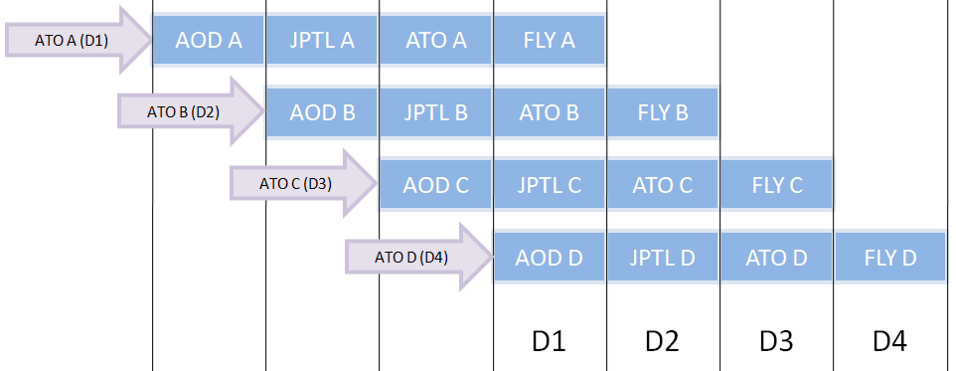

The air tasking cycle stages are described in detail below:

### Stage 1 Objectives, Effects, Direction and Guidance

The JFC provides updated direction and guidance, priorities, effects and objectives based on enemy operations and the current/expected friendly order of battle. JFC continuously assess the effects of earlier actions (earlier ATOs). This assessment is a continuous effort for everyone involved in air operations (JFACC, VIS). The JFC/LCC/MCC may also refine their concept of operations. In the D&G JFC also may provide his air apportionment guidance for further refinement by JFACC in the subsequent stages.

Assessment of earlier actions on the enemy, JFC’s guidance on air apportionment, objectives and effects will identify necessary targeting priorities for JFACC that will have an impact on the missions flown on the ATO for the day the ATO is planned.

### Stage 2: Targeting, weaponeering, MAAPand AOD

This stage is conducted prior to the signup deadline for the upcoming event and consists of 3 steps:

#### Step 1: Air request review

In this step JFACC will review any air requests that have arrived from LCC/MCC/SOCC (injects from Mission designers).

JFACC also will review Information Requirements (from VIS, if VIS is part of the campaign) and identify if there is a need to task specific flights to conduct intelligence collection sorties for this ATO. ISR flights can be used either to try to locate a TST if one have indications that it is out there, or try to locate enemy radars for further targeting with SEAD/DEAD in later missions.

#### Step 2: Targeting and weaponeering

Target Development process. The targeting process normally begins before the campaign or at the onset of planning for a campaign (as described in chapter 2, subchapter 2.1.4.2: Targeting). The Joint Target List (JTL) is normally constructed by JFC/VID with support from JFACC and VIS. The primary responsibility of maintaining the Joint Target List during execution of a campaign rests normally with VIS (if VIS is participating in the campaign), but it may also be maintained by JFACC. During execution of the campaign, the JTL continues to serve as an updated reference on all targets. The JTL contains prioritized target categories, listing specific targets. It also contains a sufficient level of detail to assist complete target identification, location, and assessment. The JTL does also have a link to graphical overlay (CombatFlite file) and may contain links to target folders for specific targets.

Targets are selected to support the objectives and priorities provided by the JFC. All potential targets are processed by JFACC which will identify, prioritize, and select specific targets that meet the JFC's directions and guidance for the ATO in planning. Targets are selected from the Joint Target List (JTL) or intelligence recommendations as the situation dictates. The end product of the target development step is a prioritized list of targets, the Joint Prioritized Target List (JPTL) that supports the JFC and JFACC objectives and conforms to guidance given by the JFC. The JPTL is a selection of targets that is valid for the specific ATO and is to be attacked during the ATO in planning.

During the weaponeering phase, JFACC quantify the expected results of weapons employment against the prioritized targets. All JPTL targets are weaponeered based on information in target folders, which detail recommended aimpoints, and weapons, fuzing, target identification and description, target attack objectives, target area threats, and probability of destruction. The final prioritized targets are then included into the Master Air Attack Plan (MAAP) with the amount of aircraft and ordnance required per target.

See annex 5 about weaponeering for understanding of what weapons that is recommended to use against certain targets

#### Step 3: Master Air Attack Plan (MAAP)

MAAP is the plan of employment that forms the foundation of the ATO. The development of the MAAP includes the review of JFC and JFACC guidance; LCC/MCC/SOCC air support plans and requests; availability of capabilities/ forces; target selection from the JPTL, required DCA (from JFACC’s plan for area air defense) and aircraft availability (pilots available to fly on the event).

The MAAP are the conceptual understanding and plan (concept of operation) for the conduct of the ATO currently in planning. The MAAP is an internal product for JFACC, and is not distributed, so it is not a formalized product that needs to have a specific format. Some examples of MAAPs:

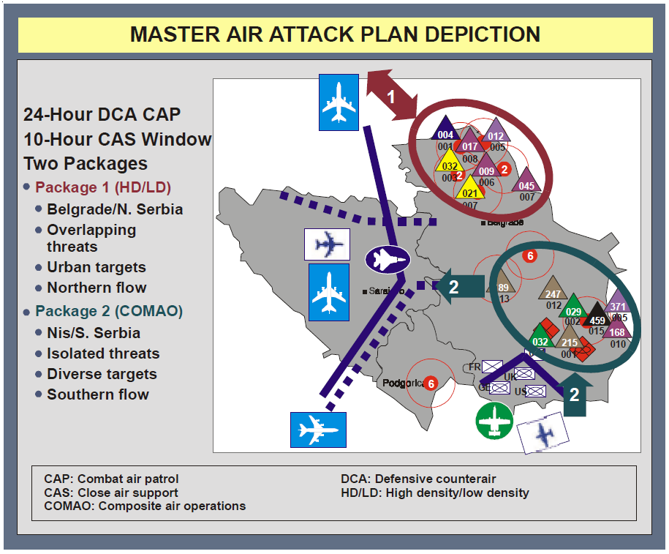

2‑4https://books.google.no/books?id=Ap_En_k7r9AC&pg=SL3-PA3&lpg=SL3-PA3&dq=jp+3-30+2003&source=bl&ots=Ost_OmnaVb&sig=ACfU3U0bd2Wf9O9gMTNRP0v-hQ6DC3ioKQ&hl=en&sa=X&ved=2ahUKEwjWjYeB14n0AhXJlosKHUpXDHEQ6AF6BAgCEAM#v=onepage&q=jp%203-30%202003&f=false

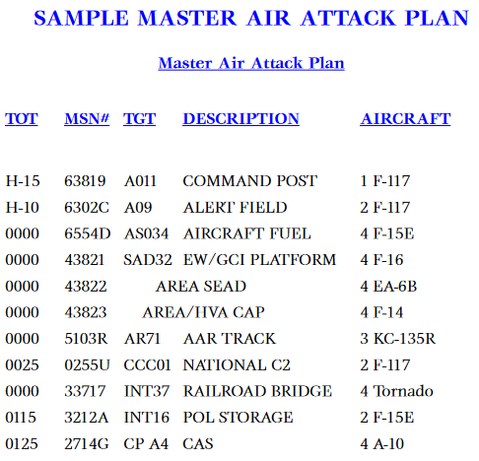

2‑5 <https://www.globalsecurity.org/military/library/policy/usaf/afdd/2-1/afdd2-1-draft.pdf>

A spreadsheet with a synchronization matrix as shown in the example below can also be used for the MAAP.

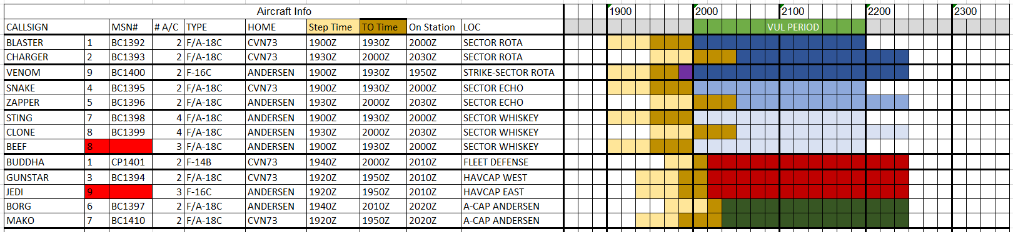

**Note:** When planning the MAAP, use the expected sorties from JAOP to plan. If there is less or more pilots signed up for an event, this will need to be ironed out in stage 3 detailed ATO development.

With stage 1 and 2 completed in the Air Tasking Cycle completed, JFACC will finish and publish the AOD which is the guidance for the ATO period (1 or more events).

The AOD is an important document, see Stage 4 Execution.

### Stage 3: ATO production

**NOTE**: If multiple events are conducted within the same ATO, stage 3 is the only stage that will be repeated for the new event on the same ATO day.

After MAAP is finished and the AOD is published, JFACC will go into detailed ATO planning for the event. Stage 3 is finalized once the deadline for the signup for an event has passed. For a Sunday combat mission the deadline for signups is normally either Thursday or Friday. Work for stage 3 can be started on completion of stage 2, but the actual numbers are not known 100% until after the deadline for signups so the finalization of the ATO is conducted at that time.

JFACC will at this time translate the MAAP into actual taskings on the ATO.

JFACC with the responsibility as Airspace Controlling Authority (ACA) and Area Air Defense Commander (AADC) will also create or update the current ACO. The ACA and AADC instructions must be provided in sufficient detail to allow pilots to plan their mission, and AWACS controllers to execute the ATO.

These directions must enable combat operations without undue restrictions, balancing combat effectiveness with the safe, orderly, and expeditious use of airspace. Airspace control instructions must provide for quick coordination of task assignment or reassignment. The Area Air Defense Instructions must direct aircraft identification and engagement procedures and ROE that are appropriate to the nature of the threat. ACA and AADC instructions should also consider the volume of friendly air traffic, friendly air defense requirements, IFF technology, weather, and enemy capabilities. ACA and AADC instructions are contained in SPINS and in the ACO. SPINS and ACO is updated as frequently as required (not necessarily per event or per ATO).

#### Airspace Control Order

Implementation of the general guidance of the ACP is accomplished through ACOs that provide specific airspace control procedures applicable for defined periods of time. ACOs are designed to deconflict and identify all airspace users and reduce the risk of friendly fire. The ACO implements the ACP and provides the details of any approved requests for coordination measures (JTACs, flights). The ACO is published as a separate document, a CombatFlite file and must be adhered to by everyone involved in the campaign/event. It defines and establishes airspace for military operations. It notifies all agencies of the effective time of activation and the structure of the airspace to be used. The ACO may include coordination measures, such as air routes, base defense zones, drop zones, pickup zones, restricted areas, etc., and FSCMs, such as the FSCL, no-fire areas, and restrictive fire areas. A change to the ACO should be distributed whenever a new coordination measure and associated procedures are established, deleted, or modified.

#### Best practice tasking

* One of the tents of airpower is centralized planning and decentralized execution. For JFACC this mean that JFACC need to centralize the planning, making sure routes, airspace, tactical frequencies are coordinated and communicated in the ATO.
* Conceptually JFACC can decide to task flights in two ways:
  + As single flights / packages doing their own thing in geographically separated areas or separated by time.
  + As a large force under one commander, in command of everyone airborne.
  + Regardless of how flights are tasked JFACC need to plan tanker tracks, AWACS tracks, routes, deconfliction measures, frequencies in order to achieve   
    advantageous synergies, establish effective priorities, capitalize on unique strategic and operation flexibility and to ensure unity of purpose, and minimize the potential for competing objectives.
* If different tasks is required to solve a single mission, creating a package with a common mission, and give each flight a separate task is recommended.
  + For example if SEAD is needed for completion of a strike tasking.
* When creating a package, make sure the best suited flight is given the mission commander role (package commander).
  + For a basic package with Sweep/Escort, SEAD and Strike the strike flight will normally have the best SA (flying in the back while SEAD and Sweep conducts operations to create a permissive environment for the strike.
* If multiple flights with the same task are required to solve the mission, have one flight as mission commander for everyone is recommended.
  + For example if several AR flights are planned to take out a large enemy formation, having one flight assigned as SCAR is recommended.
* Non permissive operations: For operations deep into enemy airspace (beyond the FLOT) it is recommended to ensure that there are not multiple flights operating in the same general area without being coordinated or deconflicted.
  + Coordination. With multiple flights operating in the same area, they should be under control of AWACS on a common frequency (For example DCA CAP’s)
  + Space. For operations in the enemy airspace it is also recommended to have packages attack in the same general direction, as this will ensure that one direction is safer, and will be used as egress direction. The concept of operations for the ATO should be visualized on CombatFlite on a threat overlay to identify issues.
  + Time. Another option is to deconflict operations by time, having one flight or package operating at the same time in the same area.
* For flights operating in the same area, they should all be operating on the same tactical frequency (as such it is not advised to have a package operating close to other packages or other operations)
* For frequency and radio planning, one frequency should be planned for internal use within the flight, and one frequency should be used as tactical frequency (with package and/or AWACS). For tactical frequency, normally a UHF frequency is used (note that most aircraft only have one UHF radio).
* Mass brief vs individual flight briefs. As much as possible mass briefs for everyone involved on the event should be avoided. (this to facilitate different start times)
* For increased SA for pilots and AWACS during their planning, it can be advisable to provide a graphical presentation or a synch matrix (for example excel spreadsheet, see below). This can be based on the MAAP, and adjusted for the signups when the final taskings have been published. (The example below may also be a basis for a MAAP, if targets/DPIs are added).



### Stage 4: Execution

JFACC have delegated authority to redirect air operations in the execution during the ATO day to AWACS controllers.

AWACS controllers must be responsive to required changes during the execution of the ATO. In-flight reports and initial battle damage assessment (BDA) may cause a re-tasking of air assets before launch or a re-tasking once airborne. AWACS are also delegated authority to retask sorties or missions to higher priority targets as necessary.

During execution, the AWACS controllers are charged with coordinating and deconflicting changes to the planned ATO with the appropriate control agencies (mission commanders, JTACs)

Due to the extensive delegation of authority from JFACC to AWACS controllers it is important that JFACC provides an AOD with the necessary direction and guidance for AWACS controllers to handle unexpected situations.

# Chapter 3: 132nd Flow

In the 132nd, the workflow for JFACC is divided into two major parts. Part 1 is conducted prior to the first campaign mission and the output will be the Joint Air Operations Plan (JAOP). If the campaign goes over a long period of time (many events), then part 1 can also be used to update or refine the plan before a new phase in the campaign is started. Part 2 is the detailed planning conducted prior to each event and the main output is the Air Operations Directive (AOD) and Air Tasking Order (ATO).

**CAUTION:**

It is very easy to get too focused on products and creating the “correct” products and documents. The most important thing for JFACC is to plan and have a plan for the campaign as a whole and specifically for each event. The products are just a way of communicating the plan to everyone involved (Mission designer, AWACS controllers, JTACs and pilots). The best way to plan is to talk together while looking at a map, once plan or concept is agreed upon, then one can use the documents to convey the plan and necessary instructions to everyone involved. With the process explained below, the production of the actual product comes last, and it is important to do the first steps/stages without focusing on the output product (JAOP/AOD)

## Part 1: General concepts

When using JFACC and VIS construct in 132nd events the following guiding principles are effective:

* One ATO Day is divided into several events.
  + This is decided between mission designer and JFACC volunteers
  + Typically one ATO day consist of minimum 2 events
  + The benefit this gives is that the products created for an event is still valid also for the next event and thus, events can be conducted at a more rapid pace. The only artificiality is that for event number two, JFACC will need to create a new ATO to facilitate for the signups on the actual date. But other products such as AOD, JPTL, ACO is still valid with the same information.
* ATO day in a campaign is given the name D1 (for first day of campaign), D2 (second day), etc.
  + If more events are conducted on the same ATO day, then the the event number for the day is added:
    - ATO Day 1, event 1: D1.1.
    - ATO Day 1, event 2: D1.2
    - ATO Day 2, event 3: D2.3.

## Part 1 Planning: Air Campaign planning

### Inputs:

* JFC Operations Order (mission designer)
* (LCC/MCC Concept of operations) (mission designer)
* Intelligence products (Mission designer / VIS)
* Draft JTL (mission designer)
* Draft ACP (mission designer)

### Output:

* JAOP (Text document)
* JTL (Approved) (Spreadsheet)
* TST Matrix (as part of JAOP)
* ACP (Approved) (CombatFlite file)

**Goal:**

The intended goal with the planning and the associated products is to have a plan and to communicate the plan to all pilots involved, the mission designers and AWACS controllers. The intention is not to create products for the products sake.

JAOP is intended for having the plan and communicating the plan to everyone, and to have the important information available for the air tasking cycle (event planning)

The approved JTL will also be used for the development of the plan (JAOP), but will also be used as a basis for targets and prioritization during events. The TST matrix is valid for all events and such a important product. The ACP is all available points to be used during the different events and having this product built will significantly easy the workload during the planning and preparation for each event (reducing JFACC workload).

**So while there are a lot of work and time consuming tasks in the Air Campaign planning, it will pay dividends when it is completed for the start of the air tasking cycle. The workload is reduced between each planned event and events can be conducted at a higher pace.**

### Step 1: Operational Environment Research.

This initial step is all about reading the operation order to get a overview of the situation. Read all intelligence reports, and especially *“XXX Country as candidate for Air attack”* provided by VID for the campaign. Also start looking at the map of the area of operations and get a understanding of time-distance for key locations (especially friendly and enemy airfields and major bases). A good understanding of enemy most likely and most dangerous course of action is also developed in this step.

### Step 2: Centers of Gravity Identification.

Getting an understanding of enemy objectives (overall + ACC+MCC+LCC), then conducting analysis on enemy COG and identify potential CV that can be attacked.

### Step 3: Objective Determination.

Based on the guidance given in the Operation Order from JFC, and the detailed knowledge about the enemy gained in step 1 and 2, JFACC should in step 3 determine all objectives needed to support the Joint Force Commander in achieving his objectives and expressed end state. If the LCC and MCC have created concept of operations for their operations, this should also be taken into consideration for JFACC’s objectives on how to support both LCC and MCC.

### Step 4: Strategy Identification.

With step 1-3 the focus have been on what to do, but here in step 4 the focus shifts to how to do it. Air power will likely be stretched between the two battles: Fight for control of the air, and support for the overall operation through strategic attack or support to LCC and MCC. With the enemy ML and MD COA and COG and own objectives available JFACC must now decide how to sequence actions to meet the objectives at the best possible way. This process is best done over a map with a timeline, and overall concept of operations can be visualized using CombatFlite.

As part of this the overall targeting strategy is also outlined here, which is about giving priorities to target categories, and target categories to available targets, so the Joint Target List is complete and can be used for execution and ATO planning (per event). With the available information understood in step 1-3 the Time Sensitive Targeting list will also be created at this step.

With the responsibilities as Airspace Controlling Authority (ACA) and Area Air Defense Commander (AADC), JFACC will as part of the Strategy Identification develop a plan for area air defense (Land based SAMs, ship based SAMs and fighter aircraft DCA CAP), and develop and implement identification and engagement procedures that are appropriate to the air and missile threats (Identification and engagement procedures are written into SPINS for the operation)

The strategy, including the area air defense plan is an input for the ACP to ensure airspace control areas/sectors are synchronized with the air defense regions/sectors.JFACC will as part of this step develop the Airspace Control Plan which is general guidance for the control of airspace and all relevant airspace control measures (routes, transit corridors, navpoints, killbox, contact points, initial points, fighter engagement zones, missile engagement zones, minimum risk routes, restricted operating zones).

### Step 5: JAOP Production

With step 4 complete, JFACC have a clear understanding of Joint Force Commanders order, and the enemy together with a good understanding of how they want to execute the campaign. JFACC now produce the Joint Air Operations Plan (JAOP) to communicate the plan to everyone involved in the operation. The JAOP will be used as guidance for JFACC personnel involved in the execution of the campaign. In addition the JAOP will be used by mission designer to place necessary aircraft at correct airbases and to create the necessary FARPs.

## Part 2 Execution: Air Tasking Cycle (per event)

### Inputs:

* JFC Direction & Guidance (Mission designer)
* VIS intelligence (Player intelligence)
* VID intelligence (Mission designer)
* Air Requests (From LCC, SOCC and MCC) (Mission designer)

### Output:

* AOD (Text document)
* ATO (132nd website)
* JPTL (As part of AOD)
* ACO (CombatFlite file)

### Stage 1: Objectives and effects. Directions & Guidance

Assess previous actions on earlier ATO days. Review JFC guidance + objectives, review JFACC objectives. Figure out what effects are needed to be accomplished on this ATO day to meet the objectives given in the JAOP+ JFC Direction & Guidance.

### Stage 2: Targeting, weaponeering, MAAP and AOD.

Start with reviewing incoming air requests (injects from mission designer) and review information requirements from VIS (if participating in the campaign) and decide if any flights are needed to be tasked to conduct ISR.

Based on stage 1, decide what targets need to be attacked from the Joint Target List (JTL). These targets are then placed on the Joint Prioritized Target List (JPTL) to be attacked during the coming ATO day. Conduct weaponeering to figure out the required ordnance and flights needed per target. This will feed the master attack air plan: JFACC will do a flights to tasks where they figure out how many flights are needed per task.

With the information so far, the AOD can be produced.

### Stage 3: ATO and ACO production

**NOTE**: If multiple events are conducted within the same ATO, stage 3 is the only stage that will be repeated for the new event on the same ATO day (due to limitation of not knowing signups and needed to make a new ATO for the subsequent for the same ATO day).

In this stage the MAAP will be translated into actual taskings on the ATO. Based on the MAAP the ACO is also created. As part of the taskings on the ATO, specific IR’s (Information Requirements) are attached to the tasking as needed.

### Stage 4: Execution

During execution JFACC have delegated authority to redirect air operations to AWACS controllers. A good AOD with communicates the intent, direction and guidance from JFACC is needed for AWACS controllers to act and handle the event in the spirit of JFACC when unexpected situations occur.

# JFACC organization

Best practice for JFACC is:

## Air campaign planning

It is recommended that one member of the JFACC team is in charge, as it will be easier to maintain overall understanding and making sure the entire team gets through the process.

## Air tasking cycle:

It is recommended, that one JFACC member is responsible for an ATO, and follow this ATO through the various steps in the air tasking cycle:

In example below, JFACC member 1 is responsible for ATO A to be flown on Day 1 of the campaign. JFACC member 1 will conduct the stages in the air planning cycle sequentially.

For the week where ATO A is flown on Sunday (D1), then JFACC member 2 is preparing the ATO for Day 2 of the campaign, while JFACC member 3 is going through stage 2 in the air tasking cycle and focusing on completing the JPTL and MAAP for the ATO for D3. At the same time JFACC member 4 is going through stage 1 and focusing on the objectives and effects for the ATO scheduled for D4.



Note that when the different stages take place is not important, and such all steps can be conducted in the same week of the event, or it can be spread out over more weeks. This is intended to facilitate for people having different schedules and different ability for the effort needed to plan for the event.

# ANNEX

## Annex 1: Worksheet for understanding objectives

Objective (XX)

Identify the enemy activity to be affected (**WHAT** do we want to do?)

Answer:

Identify the target system(s) performing the activity (Against **WHOM?)**

Answer:

Identify the specific location where enemy activity should be modified (**WHERE** do we want to affect the enemy activity)

Answer:

Determine the opportune time and duration to impact the enemy (**WHEN** and for **HOW LONG** do we want to impact the objectives?)

Answer:

Identify logical, available assets that can reach the objective target(s) within time constraints (**HOW** do we want to reach the objective).

Answer:

State attainable, quantifiable criteria against which effectiveness/success will be measured (**TO WHAT DEGREE** do we want to reach the objective)

Answer:

Perform cost analysis to estimate the cost versus potential benefit. (**HOW MUCH** will it cost to reach the objective, and is it **WORTH** it?)

Answer:

Check the objective against all known guidance. (**WHY** do we want to reach the objective?)

Answer:

## Annex 2: JAOP format (Air campaign planning)

## Annex 3: AOD format (phase or event planning)

## Annex 4: Target priorities

Priority A

* The target is essential for mission success in support of current objectives (or is a designated a Time Sensitive Target (TST).
* It is crucial to the overall success of the operation.
* It will have immediate and compelling effects.
* Its timeliness as an urgent target may not exist in the future.
* If not targeted, negative consequences may seriously jeopardize future CJTF operations

Priority B:

* Targets have substantial, but not immediate impact on the battle.
* The cascading effects this target provides may not be realized in the future.
* If not targeted on this ATO, a significant level of effort may be required later.
* If not targeted, negative consequences may significantly hamper CJTF operations.

Priority C:

* It will contribute to the battle, but it is not critical to mission success.
* It will further the success of the operation.
* It will eventually require targeting due to JFC future plans.
* If not targeted on this ATO, negative consequences will probably not impede operations.

Priority D:

* Target of opportunity if:
  + A) Other targets not suitable for this ATO.
  + B) As a backup target
* It will have minor contributions to the operation.
* It may be required for targeting, but is not time critical.
* If not targeted, no negative consequences

## Annex 5: Weaponeering

Create own table with adjusted information from this (and rest of 132nd weapons)

Include a column with what aircraft have which weapons available

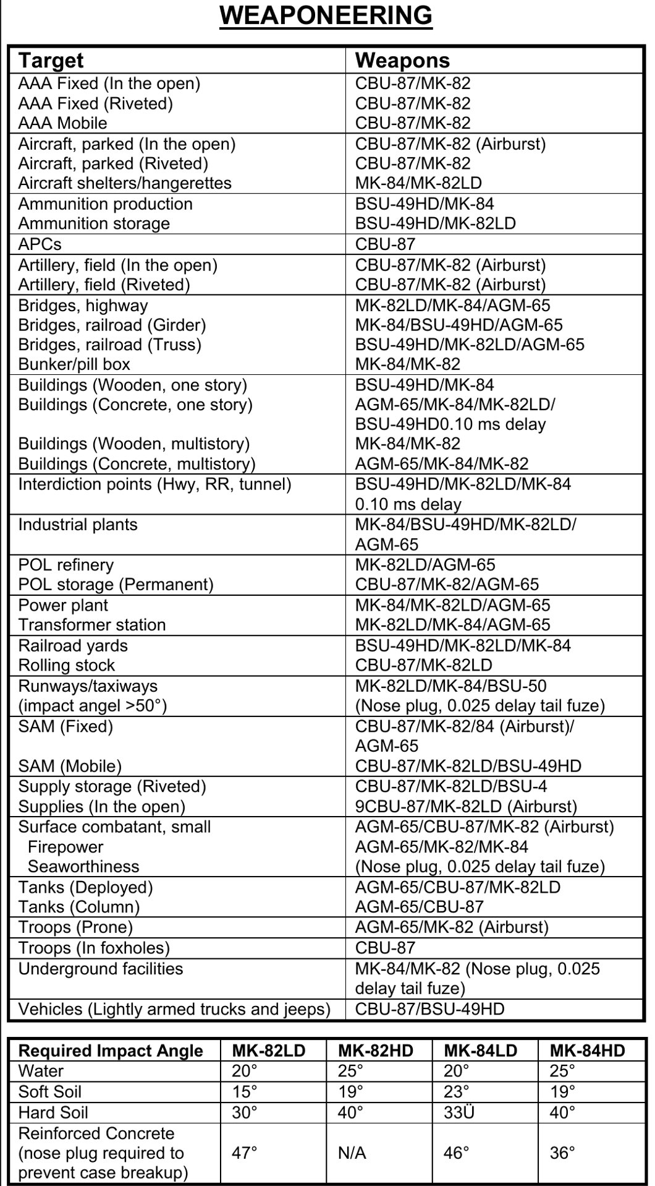

## Annex 6: Aircraft to tasking

A table with suggested tasking for the various aircrafts

Plus and minus with each aircraft per tasking?